Dear Parents and Carers,

On (insert day/date) we will be holding a ‘Sun Safe Schools Day’ to support our Sun Safe Schools accreditation and the work of national skin cancer awareness charity SKCIN.

On this day we would like all the children and staff to dress for a day at the beach, remembering their Five S’s of Sun Safety (details below) and to bring in a donation of £1 to help our school raise funds for this very worthy cause.

During our Sun Safe Schools Day, the children will be taking part in lots of fun, sun safe activities to learn about and reinforce the importance of sun safety and making healthy lifestyle choices to prevent skin cancer from developing in later life. Education regarding safe and unsafe exposure to the sun and how to prevent skin cancer, now forms part of the new PHSE curriculum – therefore, we are delighted to be dedicating a day the whole school can enjoy, whilst highlighting our commitment to protection, education and collaboration.

All children will also take part in either running a ‘mile for melanoma’ or ‘skipping a mile for skin cancer’. We have enclosed / attached a sponsorship form for your child(ren) to drum up potential support from family and friends and ask that this is handed in on the day with any funds they have managed to raise.

At the end of the school day, we will also be selling ice-creams and iced lollies to raise additional funds and invite you to pop in and see the great work the school and all the children have been doing to achieve our Sun Safe Schools accreditation.

Below are the Five S’s of Sun Safety we would like each child to remember when dressing up for the day. **Your child(ren) may wish to dress up as a sun safe superhero, like the Sun Safe Schools mascot ‘George the Sun Safe Superstar’ – see image below for guidance.**

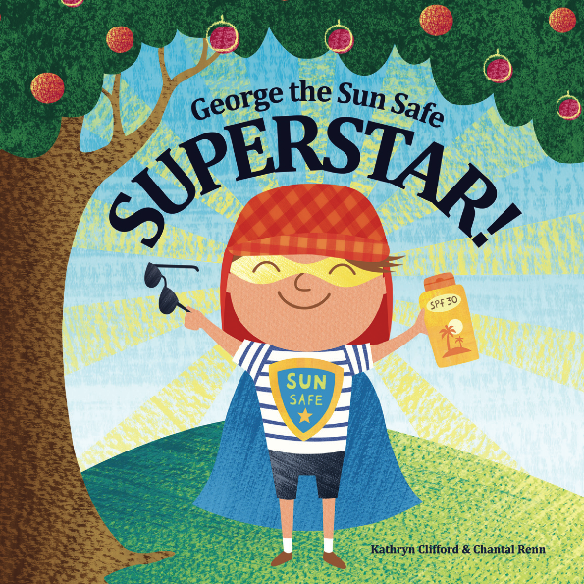

**SKCIN’S Five S’s of Sun Safety:**

1. **SLIP** on clothing – your first line of defence against UV. Please make sure, shoulders are kept covered with a

T-shirt, so no strappy dresses or vests please.

1. **SLOP** on sunscreen to exposed skin – SPF 30+ with UVA protection. Remember you will need to reapply before lunch breaks or outdoor activities.
2. **SLAP** on a wide brimmed hat to protect your scalp and provide shade to your face, neck, ears and cheeks.
3. **SLIDE** on quality sunglasses to protect your eyes from the sun’s bright light and UV rays.
4. **SHADE** from the sun when possible particularly during peak UV hours 11am – 3pm.

We are really looking forward to our Sun Safe Schools Day and thank you in anticipation of your valued support.